Computer Vision System for Tracking Players in Sports Games Research Resource #1

<https://ieeexplore.ieee.org/stamp/stamp.jsp?tp=&arnumber=914910>

Overview

The project undertaken by Janez Pers and Stanislav Kovacic was noticeably similar to my project with a few underlying differences that made it seemingly more mathematical than necessary. This includes the correction of lens distortion and the calculations of spatio-temporal trajectories, however the main goal being the development of computer vision to track an indoor sports team using a combination of both image processing and tracking methods.

Project Breakdown

The project was started by planning the image acquisition. It was instantly noticeable how crucial it would be to have correctly placed cameras with the consequence of adding a significant degree of difficulty to the tracking problem (Intille and Bobick, 1995). It was agreed that 2 static cameras would be placed directly above the court as to ensure the capture of all participants for the duration of the sports match for the most accurate results. The image below being the result.A picture containing photo, sitting, old, table

As you can see from the second image the age of the video camera used to capture the footage resulted in an extremely distorted image that would need further correction before attempting to receive any practical results.

After what looks to be an extremely tedious and in-depth mathematical process, a second image was produced that seemed to be completely rid of any distortion originally contained. Although I have not looked too harshly into process used to correct the camera issues, I do believe this is something can keep archived for future use If I run into any similar issues.

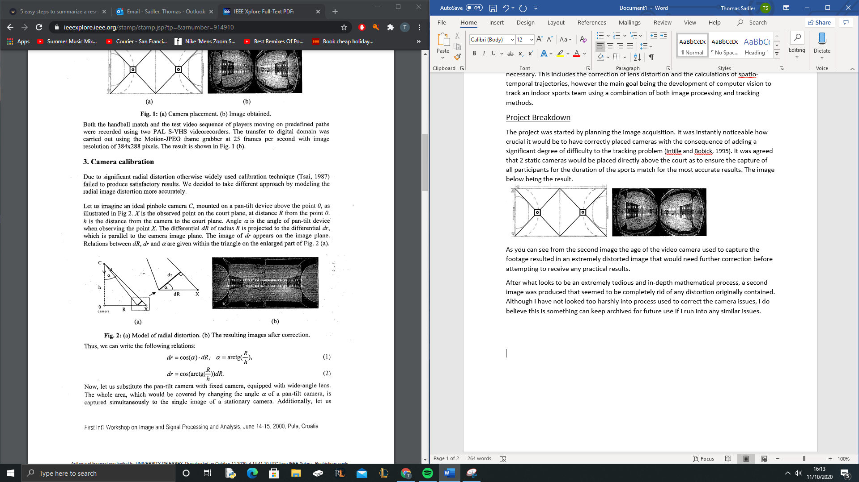

In this particular project, 3 different algorithms were developed for use in the player tracker: motion detection, template tracking and color based tracking. Each algorthim being tested and its advantages and disadvantages being listed as the project concluded.

Motion Detection

What was stated as the most “straightforward” approach was used first; this being motion detection. The idea being that Each frame in the sequence was subtracted from the “reference frame” i.e an image of the empty court, yielding the difference image.

The resulting image contained “blobs” in which motion had been detected, which were then counted, labeled and their centers of gravity calculated. However this contained a margin for error as some blobs corresponded to players whereas others caused by noise and shadows. However I don’t believe this to be an issue for my project as things like player contact, shadows and noise can be electronically dealt with.

Template Tracking

The second method I conclude to be the most inefficient of the three. This using a feature set which could be used to successfully separate objects from the background. However, this is extremely unrealistic for a number of reasons including the constantly changing shape of the players and the low resolution of the image making the extraction of certain objects extremely difficult to handle.

Colour Tracking

Colour as an identifying feature was also used in this project for the tracking of players. What this essentially means in this case was the colour detection of player outfits and the relocation of the players position depending on where that colour moves in the image. In this particular research project, there were a host of issues ranging from undefined values of hue and low pixelated images that made the detection of colours difficult.

S(X9 Y) = ((IR (X, Y) - c, 1’ + (43 (X,Y) - CcJ2 + (1, (x, - c, 1’ If , (8)

Above was the calculation used to search for the pixel most resembling the initial colour of the player after the player was seen to have move.

This Project Results

Looking at the individual results of each method clear advantages and disadvantages can be noticed. For example, the use of motion detection introduced little noise to the trajectories. On the other hand, more than one intervention per one second of playing time is required, which put enormous pressure on the human supervisor checking for errors in the tracking process. The second set of results containing the colour tracking method was much faster than the motion detection as well as having a small number of interventions however, containing by far the highest amount of noise. And finally, the third set of results pertaining to a combination of both colour and template tracking revealed that it was by far the best and most efficient method being the fastest, containing low amounts of noise and a low number of interventions by the supervisor. Below is the final table of results collected from the project.



Research Conclusion #1

This was an extremely useful research project to have found as the 3 various methods all resulted in positive findings that are useful to my own project. The conclusion of this project stated that even though the system was only tested in a classic handball match, it would be equally usegul in other team sports provided that the cameras are placed directly above the playing court.

Being that my project involves a tennis match I have concluded that a host of issues can be corrected in relation to the methods used in this system. The most notable of them being that player clashes and player color variations can be ignored as there will only be 2 participants in play at any one time.

The system used in this task is capable of outputting the positions of every player in the court coordinates in every instance of time therefore proving the similarity between the goals of our two project.



Trajectories of several players in the first few minutes of the match, obtained by motion detection algorithm.

References

References 1. Aggarval, J. K. and Cai, Q. (1 997), “Human Motion Analysis: A review”, IEEE Nonrigid and Articulated Motion Workshop, pp. 90- 102. 2. Erdmann, W. S. (1992), “Gathering of kinematic data of Sport Event by Televising the Whole Pitch and Track”, Proc. of 10th ISBS symposium, pp. 159-1 62. 3. Intille, S. S. and Bobick, A. F. (1995),”Visual Tracking Using Closed- Worlds”, ICCV ’95. 4. Swain, M. J. and Ballard, D. H. (1 99 l),”Color Indexing”, International Journal of Computer Vision, Vol. 7, No. 1, November 1991. 5. Tsai, R. Y. (1987),”A Versatile Camera Calibration Technique for High-Accuracy 3D Machine Vision Metrology Using Off-the-shelf TV Cameras and Lenses”, ZEEE Journal of Robotics and Automation, Vol. RA-3, No. 4.